ARCHITECT REVIEW
SALDEV 1371 ARR Clone Data Integrity Architect Review
FlywirePartial | Read-only non-stepped quote-line cloning best-practice review
Source | SALDEV-1371 | FlywirePartial Enterprise sandbox 00DhG0000000jOXUAY
Scope | 2 QCP scripts | 7 required ARR fields | non-stepped direct line cloning
Review date | 4 September 2026
Validation mode | Live script read-back | seven-field schema | JavaScript syntax
Decision | NO-GO - Changes Requested before story closure
Boundary | Read-only review; no clone execution, record save, metadata edit, or deployment

ARCHITECT DECISION
Changes Requested. SALDEV-1371 cannot be closed from code presence alone. Although all seven ticket field APIs exist and the null assignments are present, the clone script omits those fields from its dependency declaration and no saved quote-line read-back or SALDEV-1351 regression proves the ARR values are null outside QLE.

Acceptance and quality outcome
# | Scope | Result | Evidence
1 | Seven-field nulling logic exists | IMPLEMENTED | The clone handler includes all seven ticket fields; JavaScript syntax passes.
2 | Seven ticket APIs are valid | PASS | All seven required API names exist on SBQQ__QuoteLine__c.
3 | Runtime dependencies are complete | FAIL | The clone script declares only NS ID and Opportunity Line ID, not the seven fields it writes.
4 | Saved clone values are null | NOT PROVEN | No record-detail or SOQL read-back was performed for a cloned non-SUP line.
5 | Direct line clone is covered | MISSING | No functional test proves the explicit non-stepped quote-line clone path.
6 | SALDEV-1351 regression passes | MISSING | The APAC ARR Flow outcome was not re-tested after a clone save.

Clone path and missing acceptance proof
SALDEV-1371 requires ARR values to be null on saved cloned quote-line records for non-stepped quoting. Hiding fields in QLE is not acceptance evidence; database read-back and the SALDEV-1351 regression outcome are required.
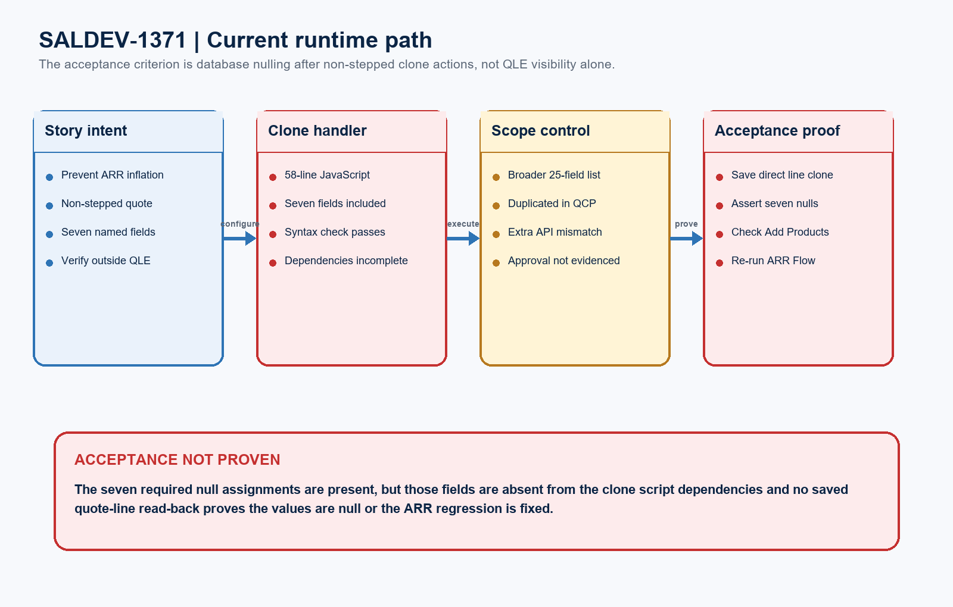
Figure 1. SALDEV-1371 clone path and evidence gap
DESIGN READING
Blue shows the non-stepped clone acceptance path. Green shows code characteristics worth retaining. Amber marks incomplete evidence. Red identifies schema or proof defects that block story closure.

Detailed code and validation evidence

1. Story and live runtime evidence
Evidence area | Observed result | Evidence
Story status | Duplicate | SALDEV-1371 states the requirement is handled with SALDEV-1427.
Target org | Verified sandbox | FlywirePartial is org 00DhG0000000jOXUAY; Enterprise Edition; IsSandbox=true.
QLE_CloneLineHandler | Runtime present | 58 JavaScript lines; all seven ticket fields appear; syntax check passed.
QCP_HideFieldInQLE | Related runtime | The before-calculate path repeats a broader ARR list; syntax check passed.
Field read-back | 7 of 7 found | Est_Annual_MM__c; Estimated_Volume__c; Annual_Number_of_Domestic_Transactions__c; Annual_Total_CC_Volume__c; Annual_No_Surcharge_Transactions__c; Annual_Total_Surcharge_Volume__c; Utilization__c.

2. Best-practice findings
Finding | Severity | Evidence
Dependency contract | BLOCKER | The seven fields written by the clone handler are absent from SBQQ__QuoteLineFields__c.
Scope control | HIGH | The implementation clears a broader 25-field set; approval for that expansion is not evidenced by SALDEV-1371.
Maintainability | HIGH | The broader ARR list is duplicated across scripts, creating drift and execution-order risk.

3. Acceptance evidence and boundaries
Test / boundary | Status | Evidence
JavaScript syntax | PASS | Both live scripts parse successfully with Node syntax checks.
Seven-field schema | PASS | All seven API names in SALDEV-1371 were found in the live quote-line schema.
Delivery evidence boundary | CONTEXT | SALDEV-1427 Apex tests do not execute or prove the JavaScript clone hook.
JavaScript unit proof | MISSING | No automated test demonstrates each ARR field changes from populated to null.
Record-level acceptance | MISSING | No saved non-SUP clone was checked outside QLE or against the ARR Flow outcome.

Required clone-data architecture and proof model
A release-ready solution should use the seven verified ticket fields, clear them once during direct quote-line cloning, preserve the source and Add Products behavior, and prove saved values outside QLE.
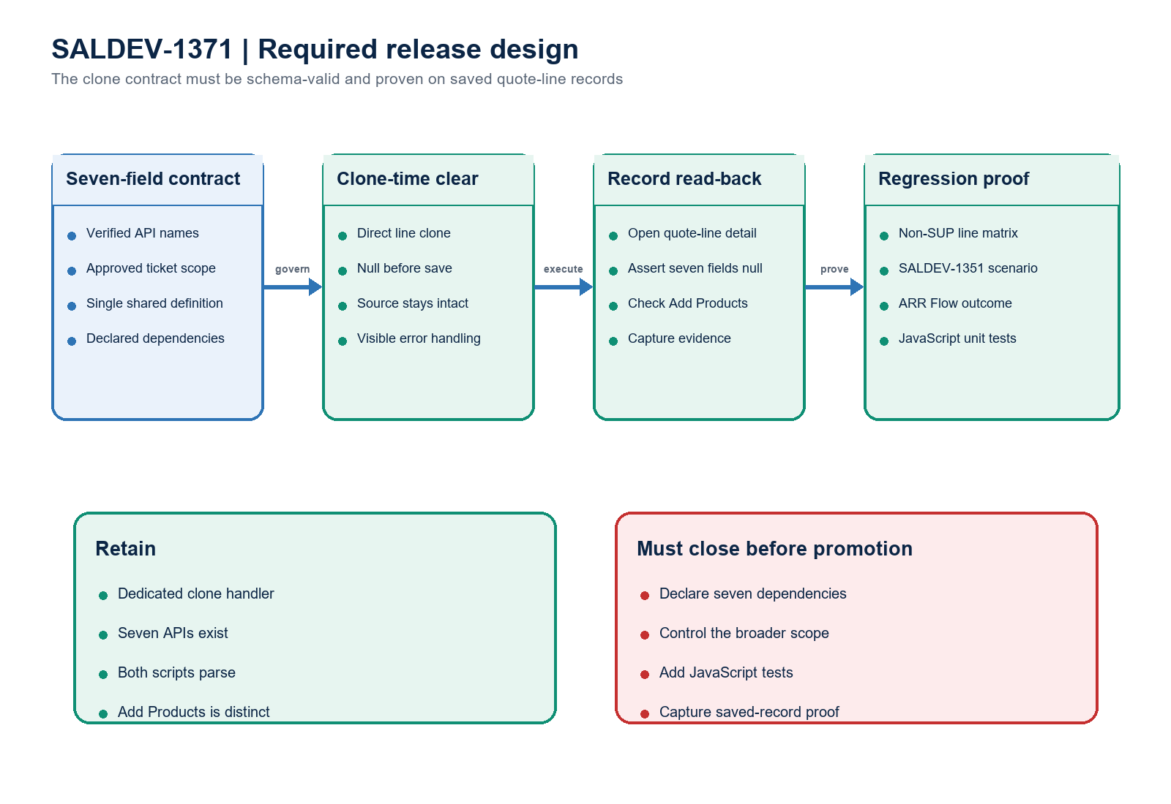
Figure 2. SALDEV-1371 required clone contract and record-level proof
Architect interpretation: the seven required API names exist and the nulling intent is visible, but a complete runtime dependency contract and saved-record proof are mandatory. SALDEV-1427 is the linked delivery vehicle; its Apex evidence does not validate this JavaScript criterion.

Completion gates
Gate | Required action | Owner | Evidence needed
1 | Confirm seven-field story scope | Product Owner | Approve the seven fields and separately govern any broader nulling behavior.
2 | Declare all seven dependencies | CPQ Developer | The clone script exposes every SALDEV-1371 field it writes.
3 | Centralize nulling logic | CPQ Developer | One canonical field definition and one clear mutation path with visible errors.
4 | Add JavaScript unit tests | Developer | Populated-to-null assertions for all seven fields; source values remain intact.
5 | Run non-SUP line-clone test | CPQ QA | Saved clone shows seven nulls outside QLE; Add Products remains unchanged.
6 | Re-test SALDEV-1351 outcome | CPQ QA / RevOps | The clone no longer inflates ARR and the background Flow result is correct.

Ready-to-paste architect response
STORY COMMENT
Architect review completed for SALDEV-1371 in FlywirePartial. Decision: Changes Requested / NO-GO for story closure. All seven ticket field APIs exist, the live QLE_CloneLineHandler includes null assignments for them, and both related scripts pass JavaScript syntax checks. However, the clone script declares only NS ID and Opportunity Line ID rather than the seven fields it writes; the implementation expands to a broader 25-field list without approval evidenced in this story; the list is duplicated across scripts; and no JavaScript unit or saved-record evidence proves a non-stepped quote-line clone has null values outside QLE. SALDEV-1427 is the linked delivery vehicle, but its Apex evidence does not execute this JavaScript path. Confirm scope, declare all seven dependencies, centralize the field contract, add exact tests, verify the saved clone and Add Products control, and re-run the SALDEV-1351 ARR regression before closing the duplicate. No deployment or Salesforce change occurred.

Evidence boundary
Evidence: the SALDEV-1371 source document, verified FlywirePartial sandbox and scripts, seven-field schema read-back, and syntax checks. No cloned records were created or saved, and no Salesforce record or metadata changes, deployment, activation, promotion, or Production action occurred.

